The feasibility of a commercial-scale recirculating aquaculture system integrating sea urchins (Tripneustes gratilla)

How to Farm the Tripneustes gratilla



Overview
Summary:

Mugenuni Research Pty Ltd (MR) has completed three years of commercial farming trials on the tropical sea urchin, Tripneustes gratilla, using a Marine Recirculating Aquaculture System (MRAS). The company built a marine circulating aquaculture system in Adelaide, South Australia, to test its science and technology using commercial techniques. The trial with the Tripneustes gratilla has provided valuable information allowing Mugenuni Research to confidently build and manage a commercial operation, refine farming techniques, and create an operation manual for full commercial production.

Key Points:
- Mugenuni Research has conducted the first commercial-scale trials of Tripneustes gratilla farming in Australia and globally.
- The trials have provided valuable information on stocking densities, cage design, raceway design, water turnover, water temperatures, and diet.
- There has been no investment in commercializing this species in Australia or the rest of the world, and there is an increasing demand for high-quality sea urchin products worldwide.

Production Potential of a T. gratilla-Ulva RAS system:
A good size commercial RAS would be capable of producing around 35,000 Market ready trips a month:
- This RAS system would produce an estimated .8 tonnes of urchin gonad per month, using the finishing diet of Ulva as recommended by the manual compared to other benthic species:
  - This system boasts a high spatial gonad production 42-73 t wet weight .ha-1/year, exceeding sea cucumber farming (3 t DW.ha-1/year) and abalone farming (135 t WW.ha-1/year).
  - Urchin production per water surface area is even more impressive, reaching 323 t WW.ha-1 compared to 135 t WW.ha-1 for abalone.

Overview of Mugenuni's Sea Urchin Commercialisation Trials
Stocking densities
The trials found that stocking densities of 8 kgs of Tripneustes gratilla per cubic meter was found to be the most optimal for commercial production. Higher densities resulted in increased mortality and reduced growth rates and less consistent commercially acceptable gonads
.
Cage/tray design
Tray design is important. The trials found that cage depth and water depth maximised growth and significantly reduced cannibalism and mortality. Cages should be designed to allow for good water circulation and to prevent escape of the sea urchins. Sea urchins rely upon currents or in the case of aquaculture water flow over their test (bodies/shell) to bring clean oxygenated water to their gills and carry away their waste.
Raceways
Raceways made of 15 mm thick PVC Foam board were found to be the most suitable for commercial production. The Raceways are designed to allow for good water circulation and easy cleaning.
Water exchange
At the suggested stocking densisty water turnover rate of at least once per hour is required to maintain good water quality, minimise mortality, maximise growth and prevent disease outbreaks.
Water temperatures
Tripneustes gratilla are tropical/subtropical and prefer water temperatures between 26.5 - 27 Celsius. This temperature promotes the best somatic growth and is a stand out result from the trials
Diets Trialing Diets for Tripneustes Gratilla
In our trial, we tested three different diets for the sea urchin Tripneustes gratilla. The first diet was dried sargassum from Vietnam. This diet was heavily polluted with heavy metals, nitrates, and silt. As a result, iit was not usable as a feed for Tripneustes gratilla.
The second diet we tested was dried Ulva grown in the waste stream of a prawn farm in Queensland. The ulva diet was of high quality, and had a very high protein level. The farmed Ulva was used as a feed for all life stages of Tripneustes gratilla. With success
The third diet we tested was an artificial diet that contained 20% dried Ulva as well as a whole range of nutrients. We used this diet in the enhancement stage only.
We found that the dried Ulva diet was the best of the three diets we tested. The Tripneustes gratilla that were fed the dried Ulva diet grew faster and had higher survival rates than the urchins that were fed the other two diets.
The urchins that were fed the artificial diet in the enhancement stage had higher gonad weights than the urchins that were not fed the artificial diet.
Conclusion
Mugenuni Research recommends that Ulva be used as a feed for all life stages of Tripneustes gratilla. MugenUni Research also recommends that the Artificial Diet not be used in a commercial operation at this stage for Tripneustes Gratilla
Sea urchins are omnivorous and can be fed a variety of diets, including seaweed, algae, and commercial feeds. The trial found that a diet of Ulva resulted in the best growth rates and roe quality. the Mugenuni trials were successful in demonstrating that the commercialisation of sea urchin Tripneustes gratilla is feasible. The company is now planning to scale up its production and enter the uni market.

Implications for the Sea Urchin Industry
The Mugenuni trials have a number of implications for the sea urchin industry. First, the trials provide valuable data on optimal stocking densities, cage and raceway design, water turnover rates, water temperatures, and diets. This data can be used by other sea urchin farmers to improve their production methods and achieve higher yields.
Second, the trials demonstrate that sea urchin farming can be a sustainable and profitable aquaculture activity. Sea urchins are relatively low-maintenance animals and can be farmed in a variety of environments, including offshore, coastal, and inland sites. This makes sea urchin farming a viable option for farmers in a variety of locations.
Third, the trials suggest that there is a growing demand for sea urchin roe in the global market. Sea urchin roe is a delicacy in many Asian cultures and is increasingly being consumed in other parts of the world. The Mugenuni trials demonstrate that there is potential for the sea urchin industry to expand and meet this growing demand.

Tripneustes gratilla
Common Names: Lamington Sea Urchin, Collector Sea Urchin, and Shirohige uni
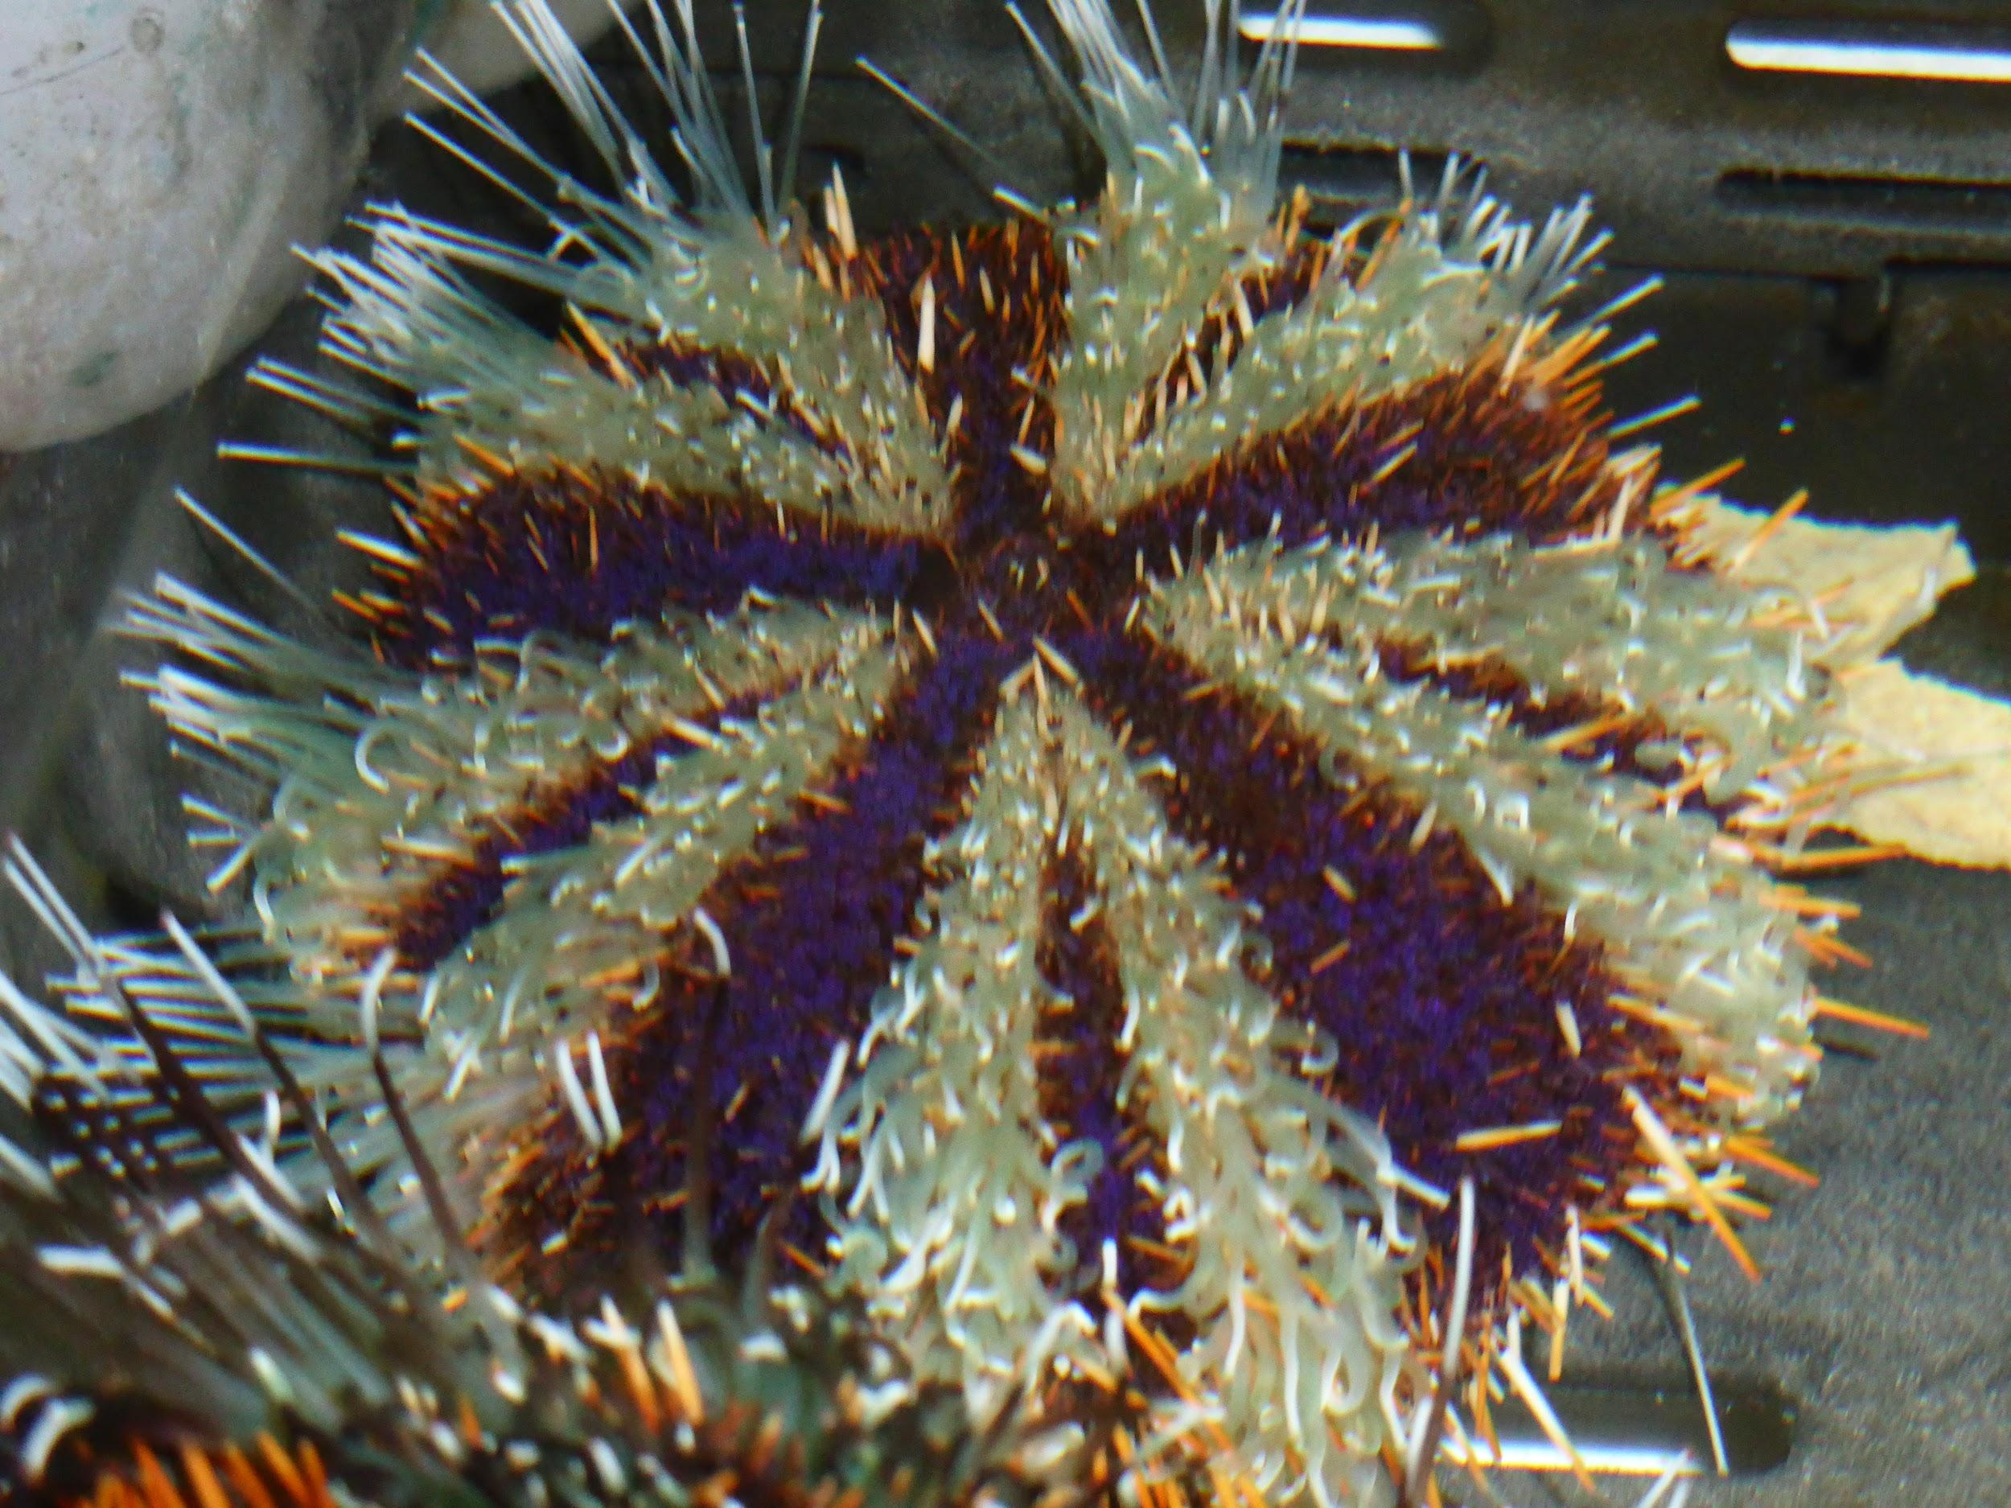
Scientific Name: Tripneustes gratilla
Distribution: Tropical and subtropical Indo-Pacific region, including the Red Sea, East Africa, India, Southeast Asia, Australia, and the Pacific Islands
Habitat: Seagrass beds, coral reefs, and rocky shores in shallow waters
Size: Test diameter: 100 mm
Appearance: Test color varies from white to purple, with stripes of red, green, or brown. Spines are short and blunt.
Diet: Herbivore, feeding on algae, seagrass, and other marine plants
Reproduction: Gonochoric (separate sexes). Fertilization is external, and larvae develop in the plankton layer for several months before settling to the bottom.
Lifespan: Up to 5 years
Ecological Significance: Important grazers in marine ecosystems, helping to control populations of algae and other marine plants. Food source for a variety of marine animals, such as fish, crabs, and sea otters.
Roe also called uni (reproductive organs or gonads) is considered a delicacy in many cultures.
Interesting Facts:
- Tripneustes gratilla is one of the most common sea urchin species in the Indo-Pacific region. It has been heavily exploited in this area.
- The roe of Tripneustes gratilla is considered a delicacy in Japan and elsewhere.
- Tripneustes gratilla is an important part of the marine ecosystem and plays a role in controlling populations of algae and other marine plants.

Tripneustes. gratilla is well suited for aquaculture unlike most of the other higher value urchin species, which are generally found in temperate waters, it has a fast growth rate and can attain harvest size within seven months or so under ideal conditions.

Sea urchin or uni is a premium seafood product that is held in high esteem by Asian, Australian, and European consumers. The demand for high quality Australian seafood products by our Asian neighbours continues to outstrip supply as these economies continue to grow. The Tripneustes gratilla, or shirahige-uni, as it is known in Japan, is a species of sea urchin that is favoured by Japanese consumers and commands high prices relative to many other sea urchin species in the world market.

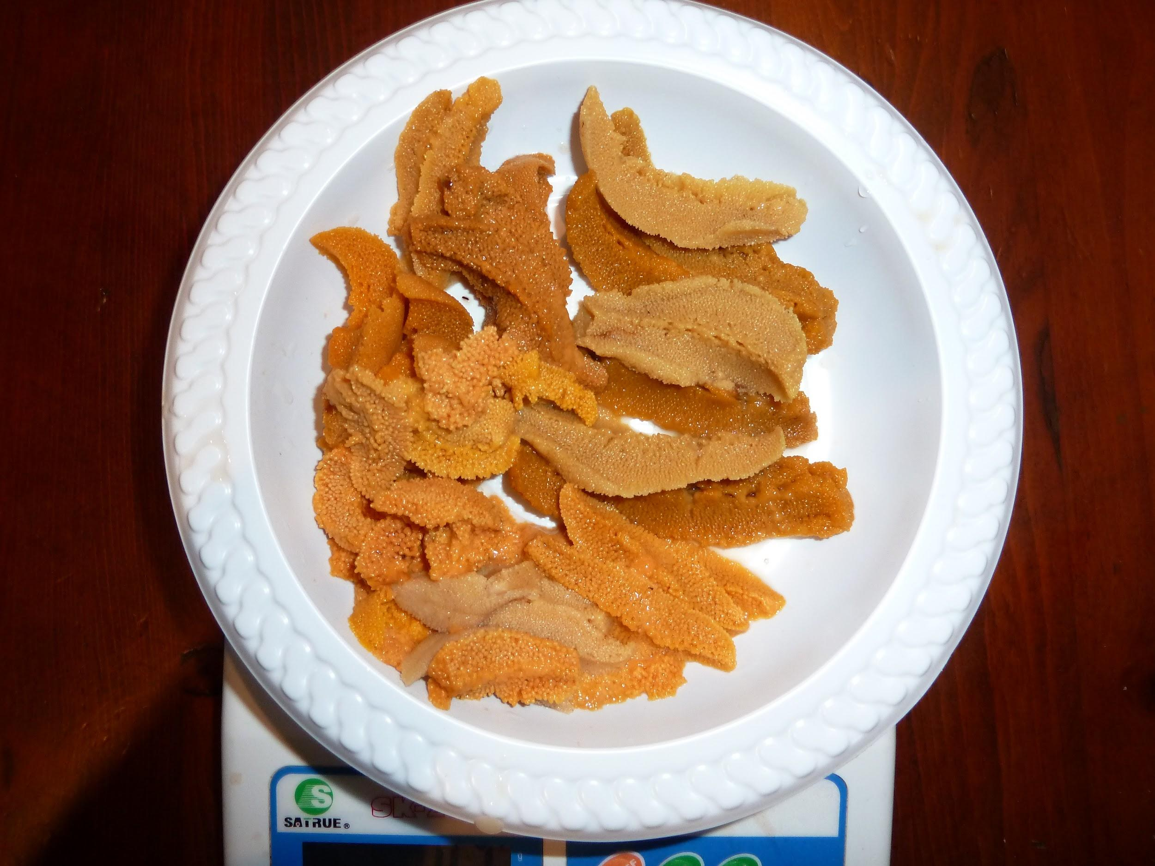

Recirculating Aquaculture System
Three Thousand (3,000) juvenile T. gratilla with an average test diameter of 10 mm were supplied by Southern Cross University.. They were delivered by air freight with a delivery mortality of about .8%. They were spread out into three 910 mm x 960 mm x 300 mm trays with a 8 mm mesh floor and sides. The cages were held in 1 meter square conical tanks which tapered down to a 40 mm waste outlet. The tanks were supplied with about 1 tank exchange an hour and aeration..
The MRAS was supplied with fresh seawater from a 23,000 litre storage tank. The storage tank was topped up when required. The seawater is consistent with that found in Gulf St Vincent South Australia.
The waste water returning from the urchin tanks passes through a 50 micron drum filter then into a heavily aerated sump for CO₂ removal. From the sump the water is pumped through a UV filter then into a biological filter and returned to the urchins. Also water from the sump passes through a Protein fractionator and heat pump in a continuous closed loop. The system water temperature is kept at 26.5 celsius. This temperature produces the optimum growth for this species.

With a diet of good quality Ulva and correct water temperature, Trips grow rapidly. To build their test (shell) use a lot of calcium carbonate. This affects the water chemistry significantly. Ph levels are maintained by a dosing system into the sump, and extra calcium carbonate is supplied as well. The sea water hardness (buffering) is maintained by a calcium reactor which slowly releases calcium carbonate, magnesium and a range of trace elements into the sump. Also a Bi-carb dosing system to maintain PH levels Salinity increases from evaporation can be automatically maintained by salinity instruments controlling automatic potable water dosing.

Initially the system was having trouble coping with high nitrate levels. It was discovered that dried sargassum from Vietnam had high levels of nitrates and heavy metals. Once this feed was eliminated from the trial the MRAS easily coped with maintaining very good sea water quality.

It was not difficult as Tripneustes gratilla produce low levels of TAN. At the stocking levels of a commercial farm: .009 mg TAN per litre, 0.666mg nitrate and 0.020mg of nitrite per litre of waste water at the suggested stocking commercial rates. Phosphate concentrations were low (average 0. 005 mg per litre. Raceway hygiene (sludge removal)also contributes to good quality sea water.

+

Basket/Tray design
In the early stages of the trial it was noticed an increasing mortality and obvious signs of cannibalism. There has been very little work done on cage design. What work has been done has not looked at cages for true commercial production. Previous research has not investigated the effects of basket depth on T. gratilla production. T.gratilla likes to get on vertical surfaces and move up towards the water surface.
High sides or deep cage walls cause the following issues:
- urchins on cage sides will not easily have access to feed which tends stay on the the cage floor
- urchins loose spines as they move across other urchins to get at feed.
- lost spines cause stress, and result in spine regrowth taking precedence over somatic growth.
- spine loss causes stress and promotes other urchins to predate on these urchins compounding loss of somatic growth and increasing mortalities.
- when cages are removed from the water within a few seconds urchins will let go and fall to the cage floor. This also compounds spine loss, stress and cannibalism causing increased mortalities resulting in production loss.
- Cage movement in and out of water adds to the problem
The cages Mugenuni Research are using for all age cohorts are .910 meters by .930 meters and have been lined with 8 mm mesh. To increase surface areas the cage has been divided into four segments with the sides at 200 high mm. The water level is set at 150 mm. Using this method the benthic area increases from .85 square meters to 1.7 square meters per tray.
Stocking density and Water Changes
The aim of commercial farming T, gratilla is to get as many as possible from 10 mm to 40 mm test diameter, the beginning of sexual maturity, as quickly as possible - 4 months. Mugenuni Research started the trials at very high stocking densities eg, 10 mm diameter urchins stocked into cages at about one thousand per square meter or using 80% of the benthic area of the standard cage size before modification. This caused issues with access to feed with larger urchins hogging feed, smaller urchins being damaged. Water quality was reduced with reductions in O2 and increases in CO2. . .This caused an increase in spine damage, cannibalism and mortality. Also significant groups failed to maintain good somatic growth.
There has been some work done on stocking densities of T. gratilla by Southern Cross University. Using their basic data MR have developed a formula which will be used in a commercial setting. Here are the densities that have been tested by and have given good commercial results .. gave good growth patterns
The chosen densities are:
- 3 kgs per square meter for the first month of the benthic area,
- 8 kgs for the third and 4th month
- 9 kgs for the fifth, sixth and 7 months,
with 1 water change per tank per hour. Basket depth is an important factor to consider in sea urchin aquaculture, as it can affect production rates.
- Basket depth can affect urchin feeding behaviour. If the feed does not sink to the bottom and can be captured and consumed from the sidewalls (such as fresh Ulva), then basket depth may not have a significant impact. However, if the feed sinks to the bottom, then urchins in deeper baskets may have to spend more time moving to find it, which can reduce their feeding rate.
- Basket depth can also affect urchin handling. Long-term urchin maintenance requires them to be removed from the water while in their baskets. Therefore, it is important to investigate the effects of basket depth on urchin spine loss during handling.
- Determining the optimal basket depth is important for maximising production rates and making the industry more feasible. If the wrong depth is used to determine an optimal stocking density, then this could lead to lower production rates. However, if the optimal basket depth is determined initially, this will provide a solid foundation for establishing production parameters.
In summary, basket depth is an important factor to consider in sea urchin aquaculture, as it will affect production rates and handling. As mentioned the tray has been decided into 4 segments, Each segment wall is 150 mm deep. The water depth is set at about 180 mm within the raceway. This gives 1.7 square meters for the urchin habitat. Tanks/Raceways
There has been essentially no work done on designing a raceway that enables a commercial farm operation to grow a cohort of 10 mm diameter T. gratilla through to market size with “AAA” grade gonads.
Initially one meter square tanks with a tapered conical bottom with the trays sitting at the very top for urchin rearing. The trays with the urchins in were covered with a 100 mm of 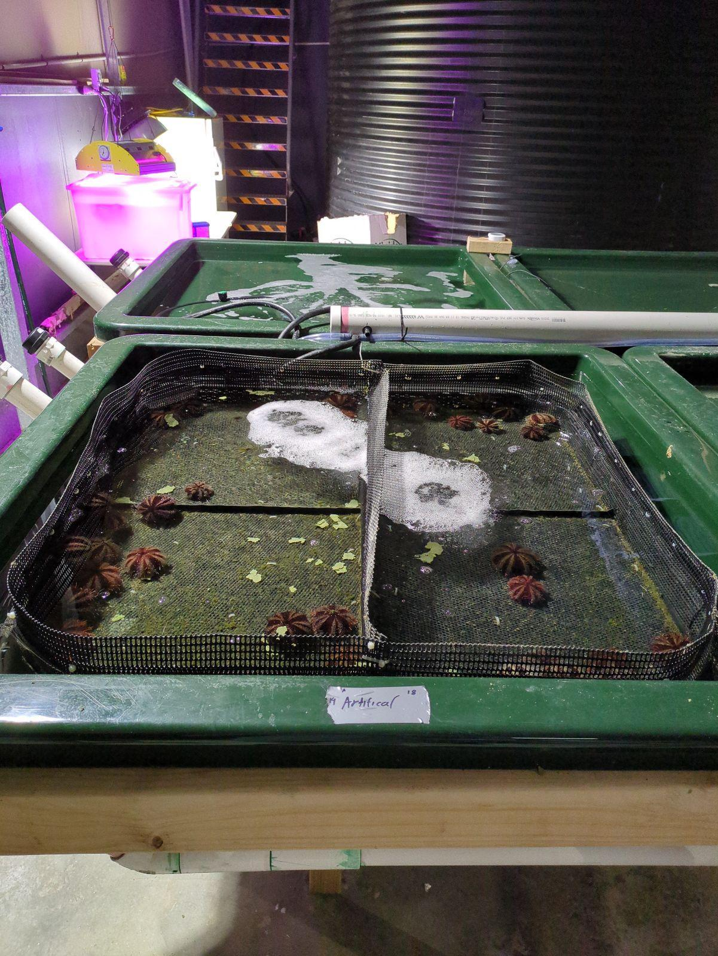
Seawater. It quickly became apparent that this system was the major cause of mortality. Based on their findings, they implemented a 10-meter long raceway with 10 trays. Water continuously flows through the raceway via 10 spouts and exits through a 80 mm outlet, ensuring proper water depth for the urchins.
This design minimizes cleaning and urchin handling, which can damage their spines and stress them, leading to reduced growth. Cleaning one 10-meter raceway takes approximately 7 minutes.

Each Raceway will be aerated which will maintain a mixing effect keeping solids partially in suspension above the bottom of the floor of the Raceway and which will aid in removing them down the Raceway towards the outflow and the 100 mm outflow which is opened to create a quick flush effect.
The plan would be to build the raceways in situ, as required, by the staff. They will be constructed using Celuka foam board foam, screws and PVC glue. The material is very light and strong. It is UV tolerant, waterproof and is food grade and will last many years.
Each tray will have its own water source so there will be 10 water spigots going into each tray and there will 10 trays per raceway so therefore each tray will have its own supply and there will be no dead water flowing over the urchins as such it will have access to good fresh water with the aeration below. The tray/cage and raceway design are unique to Mugenuni Research, and have been thoroughly tested.
Systems for suitability in growing out juvenile size T. gratilla through to commercially viable adults. Mortality rate, gonad quantity and quality (colour, brightness, firmness and texture) and cleaning efficiency associated with each containment system were the criteria for comparing the effectiveness of the systems Mugenuni Research.
We tried all sorts of tank designs metered by meter 300 millimeters deep we tried and 250 and 100 mm deep millimeters deep meter by meter the best solution we've come up with is a 10 meter by one meter Raceway which will hold ten of our trays or cages there is water feed into each tray so there's 10 spouts going down the tank at the end of the tank the way stand there is another flight 50 millimeters which water which sets the depth of the water in the tank in the right way and then there is a 80 to 100 millimeter outfit which can be flushed when required to move down waste of the right way is to minimize it's a minimize cleaning minimize moving of the urgent we do not want to move the urchins as it causes significant damage to the spines stresses as explained previously them out reduce the somatic rice and so on I think that way or up stop post up.
Each Raceway will be aerated which will also go towards maintaining a mixing effect keeping small solids partially inflation above the bottom of the floor of the Raceway and which will in remove them down the Raceway towards the outflow and that's mentioned appropriate times the 80 or 100 mil outflow is quickly opened to create a quick flash effect the tips are all be such as that the will always be at water even though the world
Each cohort will require a total of 30 raceways with a total of 300 trays. The trays will have a mesh size of 8 mm. The trays are 910 mm x 960 x 200 and divided into 4 compartments with a total benthic area of 1.7 meters. The water depth will be set at 150 mm. Each raceway will be 9.67 meters long by 1.22 meters wide and 230 millimeters deep. It will hold 1,786 liters of water, which will be exchanged once per hour. The raceway will have 10 outlets, one per tray, to ensure that all trays have fresh seawater flowing over the urchins. There will be a 0.6 meter space at the end of each raceway for cleaning without moving the urchins.
To maintain water depth, there will be an 80 millimeter outlet to waste on the end panel of each raceway and a 100 millimeter outlet, controlled by a gate valve, on the bottom of each tank. This will allow for a short flush to waste when required. Weekly cleaning times for the whole farm will be 7 minutes per raceway per week. The cleaning will consist of a flush every other day and a sweep once a week. With farm fully stocked there will be 200 raceways consisting of 7 cohorts of 35.000 each
Water exchange
To maintain good o2, salinity, alkalinity, Ph and based on our stocking densities a water Mugenuni Research has designed the raceways and trays to maximize juvenile urchin growth to 40mm in the shortest possible time with minimum mortalities.
Feeds
In the wild Tripneustes gratilla eat a range of sea grasses, and macro algae, or anything that gets in their way, dead fish, mussels and so on. T. gratilla eats a lot and does not stop eating. If the feed is there they will eat it almost 24/7. T. gratilla need to get to sexual maturity as quickly as possible to spawn before they are wiped out by wet season rain events, Cyclones and so on.
Trialing Diets for Tripneustes Gratilla
In our trial, we tested four different diets for the sea urchin Tripneustes gratilla. The first diet was dried sargassum from Vietnam. We found that this diet was heavily polluted with heavy metals, nitrates, and silt. As a result, we determined that it was not usable as a feed for Tripneustes gratilla.
The second diet we tested was dried Ulva grown in the waste stream of a prawn farm in Queensland. The Ulva was of high quality, and had a very high protein level. We used this Ulva as a feed for all life stages of Tripneustes gratilla.
The third diet was Mugenuni Research’s own Ulva. Cultivated under lights and fed on the waste stream from the RAS. This grew very well and was used to wean 1.5 mm Juvenile T.gratilla with great success.
The fourth diet tested was an artificial diet that contained 20% dried Ulva as well as a whole range of nutrients. We used this diet in the enhancement stage only, that is urchins over 40 mm in diameter.
Home grown Ulva was a great success. Urchins 3 mm in diameter moved onto it immediately. They grew to 10 mm in 4 weeks. Ten mm is considered the most viable size to start to grow out in a commercial environment. It was also used for gonad enhancement on a small sample of adult urchins (5) with very good results.
Ulva has several advantages as a feed additive for sea urchins. It is a fast-growing algae that is widely available and can be easily cultivated. It is also a good source of protein, energy, and other nutrients. Moreover, Ulva has been shown to act as a feeding stimulant for T. gratilla.
MR’s choice for commercialisation
Mugenuni Research purchased dried ulva from two sources One source was from Tasmania which had a small amount of cladophora mixed in with the dried ulva. Mugenuni Research thought it would be worth trying due to its cost of freight only. The urchins eat it and grew well with good somatic growth to 40 mm. It was not a viable feed for gonad enhancement.
Mugenuni Research also purchased dried ulva from bioremediation trials being conducted on a prawn farm in Queensland to clean up sea water before it was returned to the environment. This was of very high quality with a protein content of over 30%. It was fed to all life stages of the urchin - grow out through to gonad enhancement, with good commercial results.
The urchins that were fed the artificial diet in the enhancement stage produced the highest volume gonads but only but only 60% were usable.
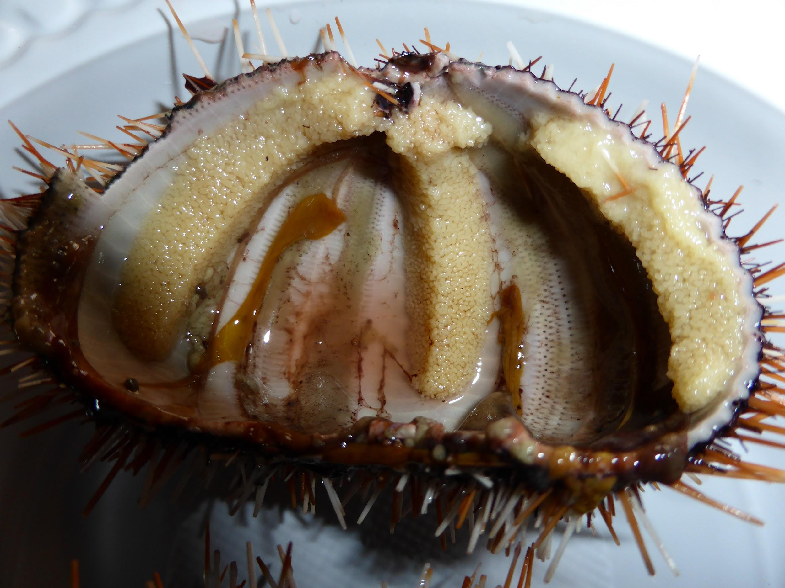
Conclusion
Mugenuni Research recommends that Ulva be used as a feed for all life stages of Tripneustes gratilla. In the enhancement stage the average gonad quality was at least 90% commercially acceptable. The urchins enhanced on the Artificial diet had larger gonads about half were not commercially acceptable.

Lighting
Juvenile T. dratilla fed Ulva grows a little faster in ambient light than in 24 hour darkness. The amount of light from a daylight LED “fluro” was about 1000 LUX at the surface of the water of the raceway; 12 hours on, 12 hours off. As they reach sexual maturity - about 40 mm test diameter. The same light should be set at 16 on and 8 off to maintain the gonad in a growing mode but in a state of immaturity during the final 3 months, from 40mm diameter to 60 ~mm diameter market ready urchin weighing up 150~gms. With 20 - 25 gms of roe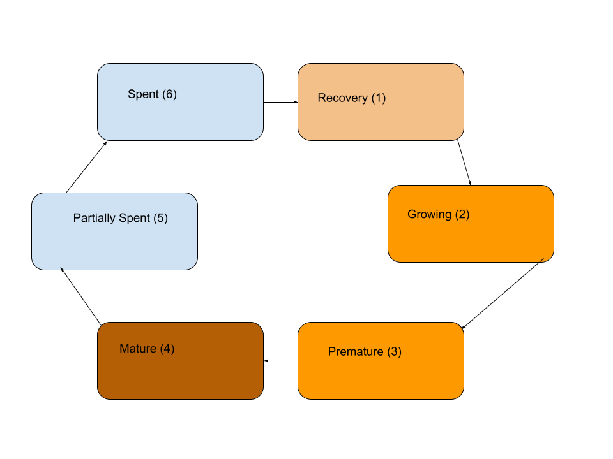
The idea is to keep the gonad development stage between 1 (recovery), 2 (growing), and 3 (Premature). These three stages produce the best roe for eating with the best texture, the best colour and most important of all the classic umami-ness of the Tripneustes gratilla.
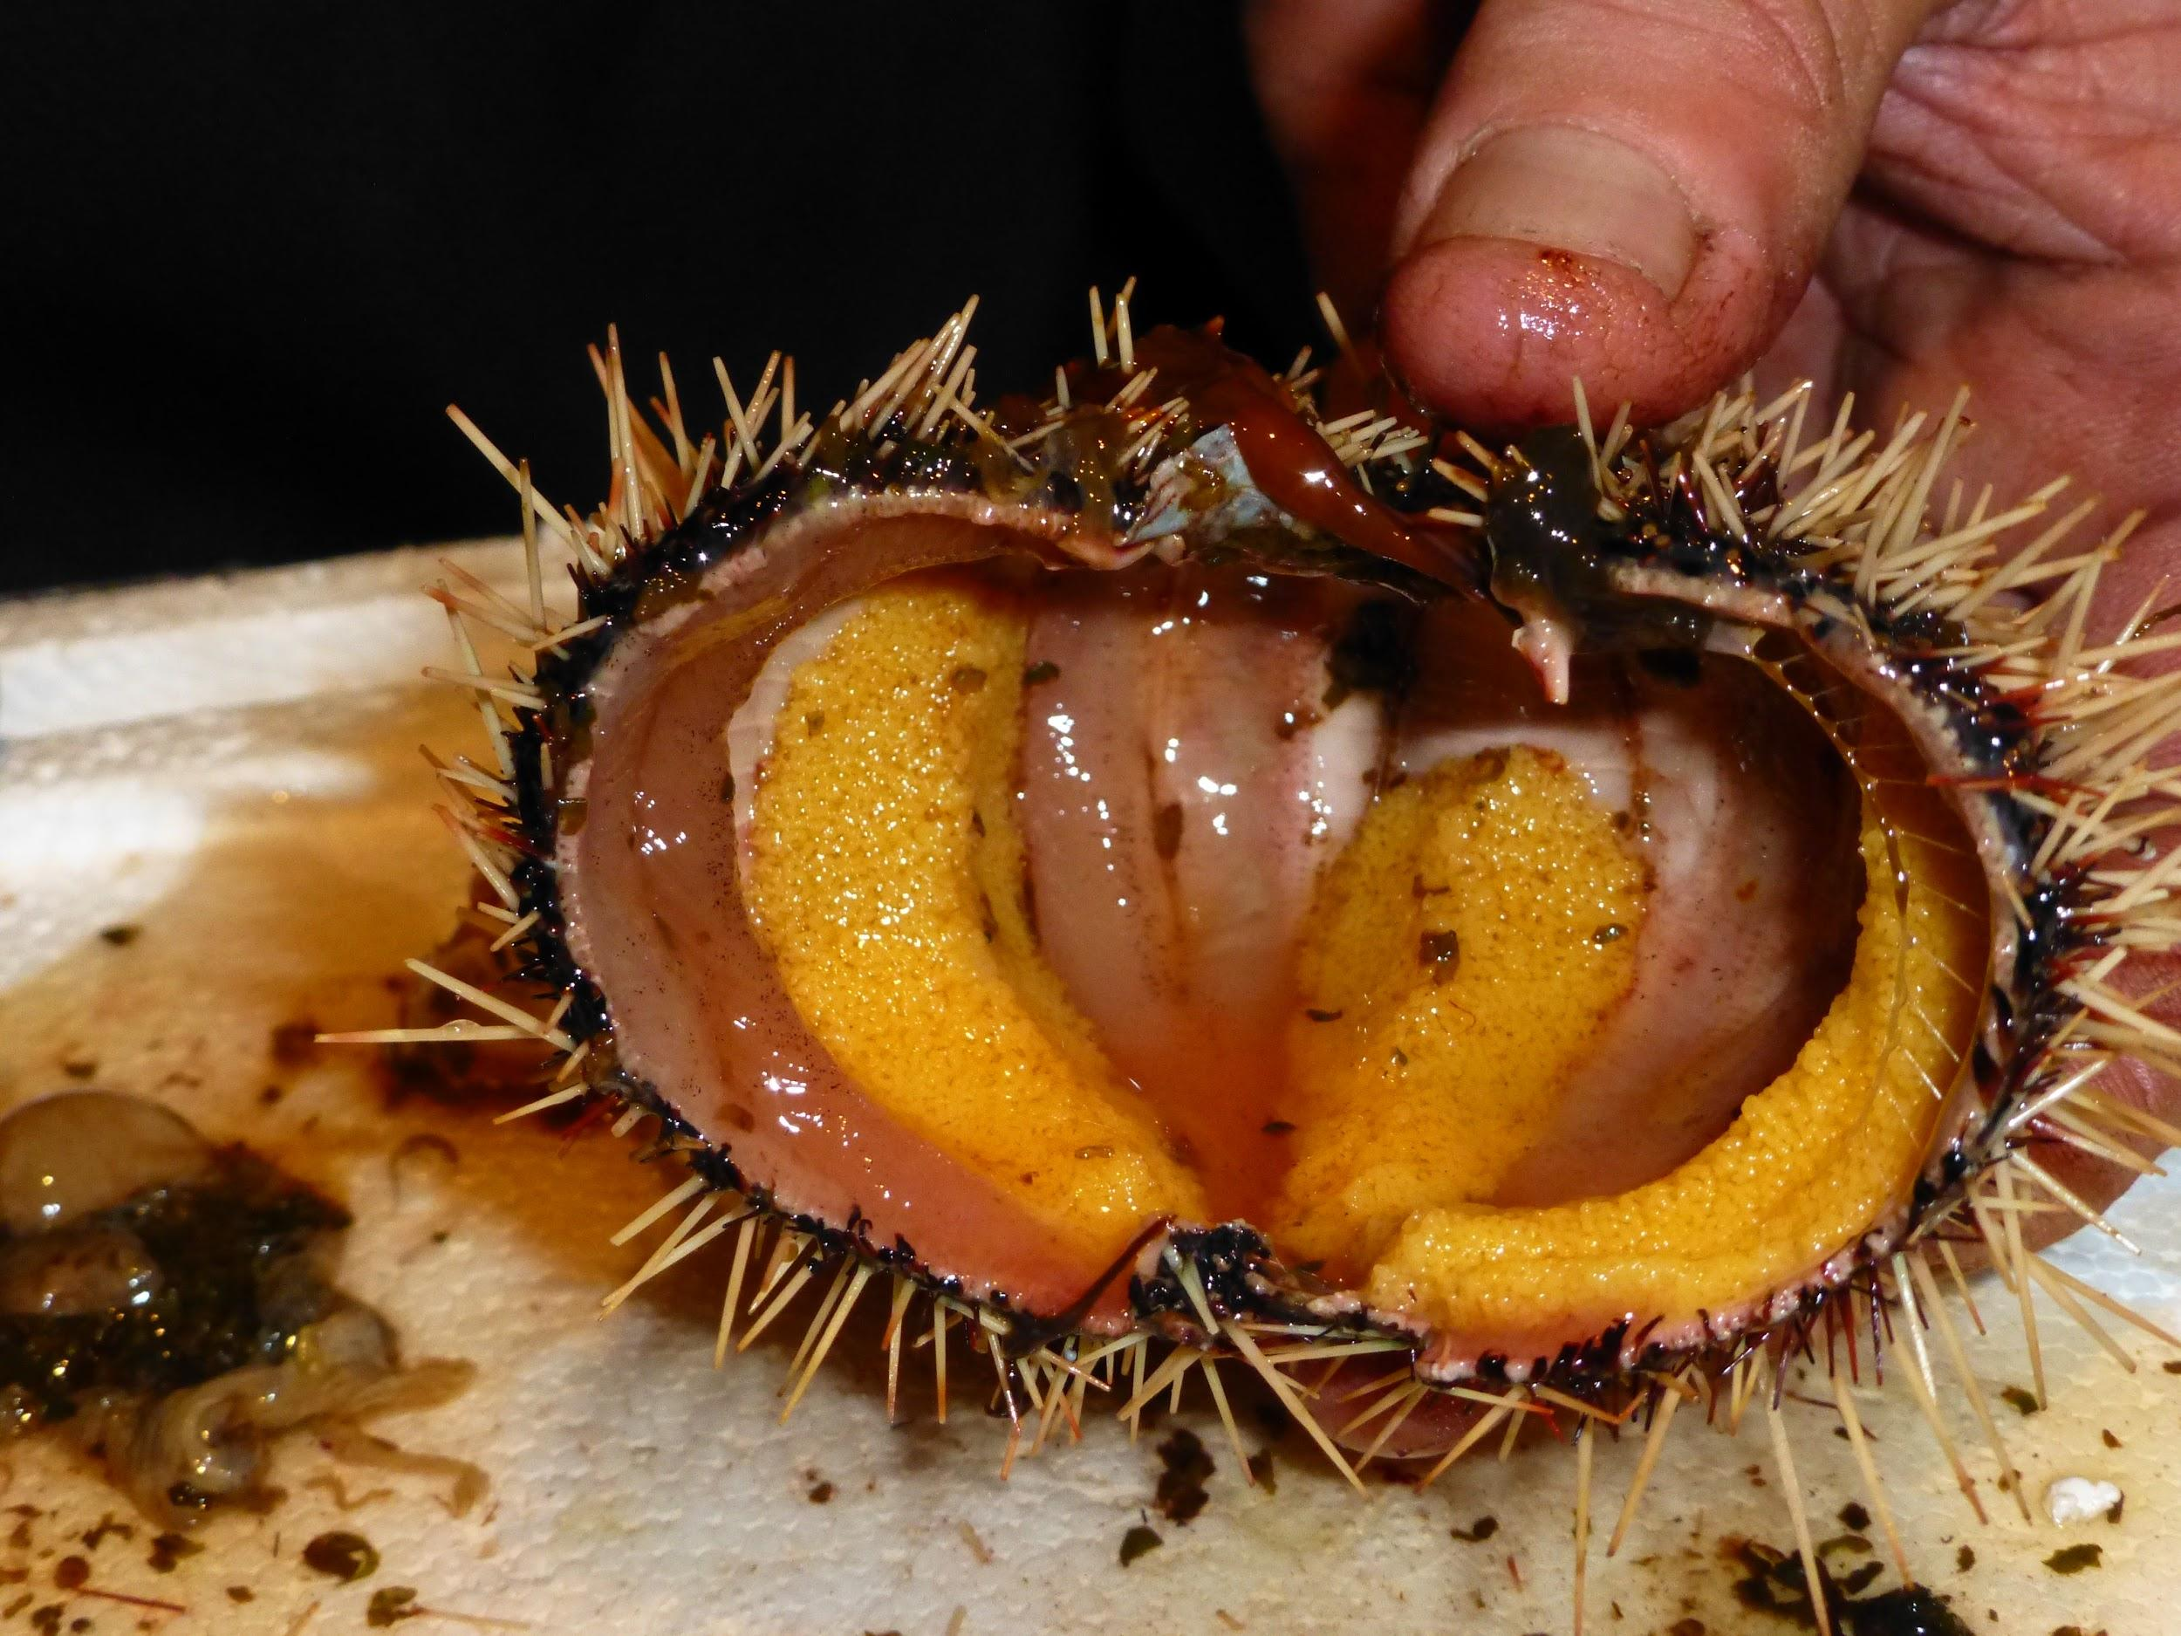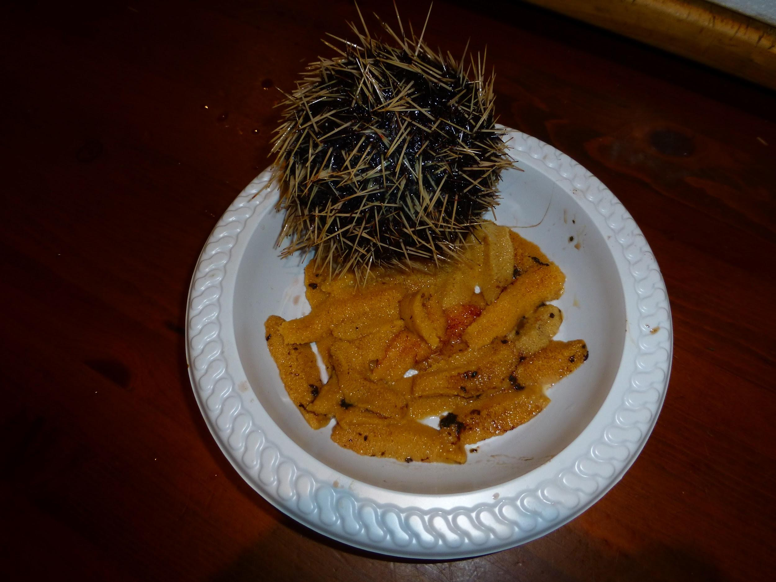

Gonad Enhancement
The time budget to get a 10 mm diameter T. gratilla to 40 + mm was 16 weeks. MR has done it consistently in 12 weeks. The first 4 months are spent making sure everything is done to get the trip from 10 mm diameter to beginning of sexual maturity at 40 mm test diameter. When the trip has reached 40 mm the animal is subject to increasing daylight hours (16 on 8 off). The urchins were split into two groups. The ulva fed group (U) and the Artificial diet Group (A). The U group continued to feed on Ulva at 6% per day. The A group were fed an artificial diet at 1.5% of their body four times a week.
After 12 weeks the two groups were processed. Group A had an average test diameter of 71 mm, average gonads weighing 40 gms average wet of 160 giving a GSI% of 25% An excellent roe volume. Unfortunately about 60 % of them had roe which was commercially unacceptable. Group U stats were an average diameter of 68 mm, an average weight of 150 gms, and gonads weighing 20 - 25 gms. The gonad recovery was between 90 - 95% commercially acceptable (see image above).
Mugenuni Research suggests that a commercial operation should take into consideration that the GSI% and test diameter have no relationship. The test diameter increases in size quickly at first until it reaches around 40 to 45 mm it then starts to slow down whereas the gonad continues to increase in size exponentially.
Juvenile Tripneustes gratilla sea urchins grow slightly faster in ambient light than in complete darkness. When the urchins reach sexual maturity (at a test diameter of around 40mm), the light should be set to 16 hours on and 8 hours off to keep the gonads in a state of recovery.
Once the urchins reach a test diameter of 40mm, the day length must be increased to 16 hours on and 8 hours off for a period of 3 months to slow down or suspend gametogenesis and gonad maturation. This is done to delay the production of eggs and sperm or onset of gonad maturation so that the urchins can be marketed during periods outside of the normal season. Processing the T. gratilla showed that urchins exposed to a short day were much more advanced reproductively, with the majority of urchins being in a mature or spent state (spawned), compared to those exposed to a long day (16:8 hour), which were mostly premature and of good quality. A very important statistic is that 90 - 95% or more of the T. Ecological benefits:
Computer Aided Vision.
A work in Progress
Potential applications of computer vision for sea urchin counting and measurement in aquaculture
- Monitoring sea urchin populations and assessing their health: Computer vision algorithms could be used to monitor sea urchin populations in aquaculture systems. This could be done by regularly scanning the system for sea urchins and tracking their numbers over time. Computer vision could also be used to assess the health of sea urchins by identifying abnormalities in their appearance.
- Tracking sea urchin growth and development: Computer vision algorithms could be used to track the growth and development of sea urchins in aquaculture systems. This could be done by regularly measuring the diameter and weight of each urchin. Computer vision could also be used to identify sea urchins that are ready to be harvested.
- Estimating sea urchin biomass: Computer vision algorithms could be used to estimate the biomass of sea urchins in aquaculture systems. This could be done by counting the number of sea urchins in the system and measuring their average diameter and weight.
- Automating the harvesting process: Computer vision algorithms could be used to automate the harvesting process of sea urchins from aquaculture systems. This could be done by using the algorithms to identify sea urchins that are ready to be harvested and then directing harvesting robots to those locations.
Conclusion
Computer vision is a promising new technology that has the potential to revolutionize the way that sea urchins are counted and measured in aquaculture systems.
Month to Month
Conducted by Southern Cross University, Coffs Harbour and others.This section outlines a seven month production cycle per cohort for cultivating T. gratilla in an MRAS system. Since no commercial T. gratilla-Ulva IMTA systems currently exist, this cycle is based on:
- Experience: Knowledge gained from existing aquaculture facilities and practices.
- Findings: Data from the Mugenuni Research commercial trial.
- Laboratory trials: Results from controlled experiments

Monthly Rotations
The farm operates on a monthly cycle, involving the following key activities:
- Harvesting: Market-sized adults are harvested each month. Either for live domestic sales and export or processing and packing roe on-site.
- Grading and stocking down: Remaining urchins are graded and distributed across various tanks and baskets to maintain optimal stocking density
- Stocking new 15 mm juveniles: Once a month, a new cohort of 38,000 15 mm juveniles are introduced to the system. They are initially stocked at a density that will reach optimal levels after 4 months of growth.
- feeding of all raceways every second day at a rate of 6% of body weight per day of fresh Ulva
- Raceway Cleaning
Keepinging to the Stocking Density:
- Grading down occurs monthly for all cohorts as they require more space due to their growth.
- This space is created by the monthly harvest of market-sized adults.

